REPORT

!REWRITE!! Report 14 p., 1 p., 3 pic., 9 references.

MOTION CAPTURE TECHNOLOGY, 3-D ANIMATION GENERATION, 3-D ANIMATION MODELING, ANIMATION OF WALKING, BIG DATA PROCESSING, FBX DATA PROCESSING, NEURAL NETWORKS, NEURAL NETWORKS FOR THE ANIMATION.

This report contains the results of the framework development for processing large database of FBX files, obtained from motion capture data collection.

The goal of the work — the review of the 3-D models animation principles, formulation of the new approach to the animation modeling and the development of the environment for the animation modeling.

The research work included the review of the 3-D models animation principles in the interactive environment. The principles of human animation are formed based on this review and the model of the people’s movement is developed in form of 3-D application.

This application can be used for crowd movement modeling and for the human walking visualization in the project of the various orientation.

CONTENTS

REPORT 2

CoNTENTS 3

INTRODUCTION 4

the mAIN PART 5

1. Animation. 5

1.1. Motion capture technology 5

1.2. Motion capture approaches to animation 6

1.3. Neural networks technology 6

1.4. A mixed approach to animation via neural networks and motion capture 7

1.5. Platform for animation modeling 7

LITERATURE AND REFERENCES 10

INTRODUCTION

It is known fact that modern 3-D applications – games, virtual reality applications and e t.c. – apply the interactive models for creation of the various actions on the screen (walking, running and e t.c.) Animation is the instrument of the virtual realistic movements modeling. The goal of animation algorithms is calculation and handling of the model’s data. This calculation helps to perform necessary transformations for movement modeling. There are many approaches to the implementation of animation, but movements seem unrealistic and unnatural, and the calculations require a significant amount of computational resources. That’s why various researches are concentrated on creation of the realistic movements and on the reduction of the computational resources. In this report a new approach to the animation modeling is formulated. This approach based on the motion capture and neural networks technologies. The proposed approach have a set of positive items, which outstand it from the others:

* The frames of the animation are calculated continuously, and not at the discrete moments of time.
* The movement is modeled basing on the real data, and the mathematical model provides flexibility and realistic visualization of the new movements with the changing of time parameter.
* There is no necessity for the generation of the new animation by hand with the help of 3-D modeling programs.

This way, model, which is built once, allows to retrieve new frames for the any moment of time fast and doesn’t require continuous complicated calculations.

The goal of this work is to implement the platform of the movement animation modeling and also review and analysis of the works, related to animation modeling.

The tasks of this practical work were:

* The research of the 3-D animation and motion capture modeling areas.
* To form a new approach to the animation modeling, based on motion capture technology.
* To implement an instrument for animation modeling and visualization of the human and crowd movement process.

THE MAIN PART

1. Animation.

Generally, “animation” is a process of implementing movements of the virtual 3-D model: for example, running, jumping, walking and e t.c. There are many approaches [1][2][3] to perform the animation of virtual models, and nowadays researches are directed to the ways of creating more realistic animations. Many computer graphics applications, such as computer games, human computer interaction and virtual reality, require realistic 3D models of human bodies[1]. In this research attention is focused on motion capture approaches, which apply interactive 3D sensors, placed on human bodies, to retrieve the data which maps the real movement frames to the computer frames. Motion capture data is a great expectation in generation of animated 3-d models, which seems to be more natural. But motion capture has a disadvantage: it lacks flexibility[4]. That’s why an additional technology for movement generation is required to reduce rudeness of the transitions between the joints’ postures.

* 1. Motion capture technology

Motion capture (Mo-cap for short) is the process of recording the movement of objects or people. It is used in military, entertainment, sports, medical applications, and for validation of computer vision[5] and robotics. In motion capture sessions, movements of one or more actors are sampled many times per second. Whereas early techniques used images from multiple cameras to calculate 3D positions, often the purpose of motion capture is to record only the movements of the actor, not his or her visual appearance. This animation data is mapped to a 3D model so that the model performs the same actions as the actor. On the picture 1 an example of motion capture data processing is presented.

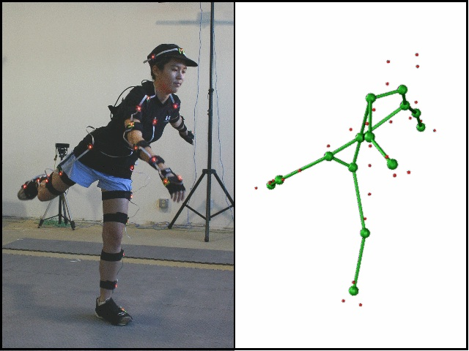

Picture 1. An example of motion capture dataprocessing.

* 1. Motion capture approaches to animation

In [4] a statistical algorithm, which learns on motion capture examples, is presented. A Hidden Markov Model is applied to generate the joints’ postures of two people’s handshake at the different moments of time. However, classification of the joints is required. Probabilistic estimation of every motion example is also necessary, to determine whether the example belongs to the cluster or not. In our approach there is no need to classify anything, as the positions of movement postures are produced by extrapolated function. In[6] the PCA technology is applied to animation parameters generation, but data is modeled and extrapolated with the linear model and depends on movement speed. One of the major novelties of our approach is the calculation of the derivatives whose primitives approximate discrete functions of motion capture parameters to perform and extrapolate body movement in a certain moment of time.

Raw motion capture data can be presented as a set of articulated joints and their angles at discrete time intervals. Also data can contain raw 3-D points, taken directly from sensors. The dataset needs to be handled and reshaped to the form of a function of time t instead of the set of unstructured points. There are several ways to form a function of time from raw data: calculation of an angle-axis representation of a single joint[4], skeleton fitting from raw point data[7], inverse kinematics techniques [8].

* 1. Neural networks technology

An Artificial Neural Network (ANN) is an information processing paradigm that is inspired by the way biological nervous systems, such as the brain, process information. The key element of this paradigm is the novel structure of the information processing system. It is composed of a large number of highly interconnected processing elements (neurones) working in unison to solve specific problems. ANNs, like people, learn by example. An ANN is configured for a specific application, such as pattern recognition or data classification, through a learning process. Learning in biological systems involves adjustments to the synaptic connections that exist between the neurones. This is true of ANNs as well. On the picture 2 an example structure of neural network is presented.

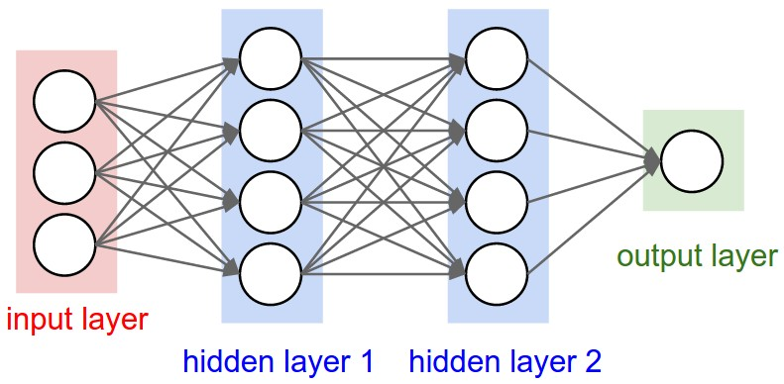

Picture 2. Neural network structure

* 1. A mixed approach to animation via neural networks and motion capture

Our approach combines neural networks and motion capture technologies for human-like 3-D animation generation. Neural network is trained on the motion capture data to produce better parameters of virtual skeleton movement. Another novelty of this approach is the non-linear model which stands for computation of every neuron in neural networks. It is done due to timely solving of the system of differential equations. This model can perform better than linear and sigmoid “rigid” models on complex tasks with many factors which are usually solved by neural networks[9].

The algorithm is the following:

The set of parameters is retrieved from motion capture data of human movement. Parameters are presented in form of bones and angles data. Every parameter is presented as a function of time. Thereto neural network also generates a function – a solution of the system of differential equations, and every neuron stands for one single equation. Final solution is on the output. By learning a network on the existing motion capture data, we can select necessary weights for neural network so it will generate a function which fits the function produced from the source data. Then we can get value of a movement function from the neural network for any moment of time.

* 1. Platform for animation modeling

To test the output of neural network and watch real-time virtual human movement a platform for animation modeling was developed. A platform presents a game-like application, where user can watch many people walking. An animation is performed by standard way of coordinates and transformation matrixes calculation. Human agents which are modeled this way will be compared to the agents whose animation is performed via neural network. The modeling space is presented on the picture 3.

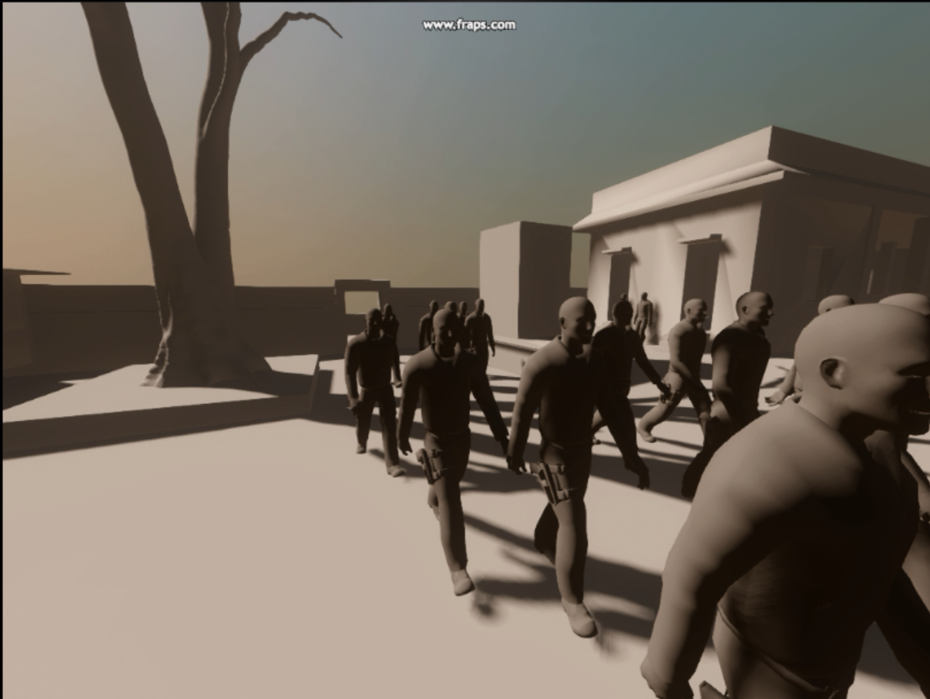

Picture 3. The space for animation modeling

On this picture a 3-D space for modeling human movement is presented. The frames of the movements are calculated in advance and saved to the array. Index of the next frame for a human agent, which picked randomly, is calculated as a sum of a time parameter of the game and shift to the random place of the array. This way the movements can be customized.

This game-like system for animation modeling can be a starting platform for modeling animations performed by neural network.

CONCLUSION

During the practice work the research of the approaches to the animation and has been performed. Also related works about animation and motion capture technologies are ovserved and pros and cons are emphasized. A new approach to the animation modeling is formulated based on the both mocap and neural networks technologies and also related works review. An instrument for animation modeling is implemented in form of 3-D application, which user can observe personally from the first-person view. The future work plans include the collection of the mocap data and the implementation of the neural network algorithm based on this data

LITERATURE AND REFERENCES

1. Tong J., Zhou J., Liu L., Yan H. Scanning 3D Full Human Bodies Using Kinects.// IEEE Transactions on Visualization and Computer Graphics archive ­­– 2012 – Vol. 18 (4) – pp. 643 – 650.
2. Weise T., Bouaziz S., Li H., Pauly M. Realtime performance-based facial animation. // SIGGRAPH '11 ACM SIGGRAPH 2011 papers – 2011 – Article No. 77.
3. Li H., Yu J., Ye Y., Bregler C. Realtime Facial Animation with On-the-fly Correctives.// ACM Transactions on Graphics (TOG) - SIGGRAPH 2013 Conference Proceedings – 2013 – Vol 32 (4). –Article No. 42.
4. Molina-Tanco L., Hilton A. 2000 Realistic Synthesis of Novel Human Movements from a Database of Motion Capture Examples. //Appeared in Proceedings of the IEEE Workshop on Human Motion HUMO 2000.
5. Noonan D., Mountney P., Elson D., Darzi A. and Yang G.-Z. A Stereoscopic Fibroscope for Camera Motion and 3D Depth Recovery During Minimally Invasive Surgery.//In proc ICRA 2009 , pp. 4463-4468.
6. Glardon P., Boulic R., Thalmann D. PCA-based walking engine using motion capture data. //In Proceedings of Computer Graphics International 2004, pages 292- 298, June 2004.
7. M-C. Silaghi, R. Plankers, R. Boulic, P. Fua, D. Thalmann. Local and global skeleton fitting techniques for optical motion capture.// CAPTECH'98: Modeling and Motion Capture for Virtual Environments. 1537:26­­–40, Nov. 1998
8. Tang, W., Cavazza, M., Mountain, Mountan D., Earnshaw R. A constrained inverse kinematics technique for real-time motion capture animation. The Visual Computer (1999) 15: 413. doi:10.1007/s003710050188.
9. Acka H., Alassar R., Shebadeh Y.M., Covachev V. Neural Networks: Modelling with Impulsive Differential Equations. 5—10 July 2004, Antalya, Turkey – Dynamical Systems and Applications, Proceedings, pp. 32—47.